

QAgent USer MAnual FOR JDE

Table of Contents

1. Introduction 2

2. Downloading QAgent & Starting Audit 2

# Introduction

This document will help QCloud tenants to setup and configure QAgent to run an audit for JDE

# Downloading QAgent & Starting Audit

Once the sales user of QSoftware approves the audit, the customer (whose email was specified in the Audit Request Form) will receive an email notification as below.

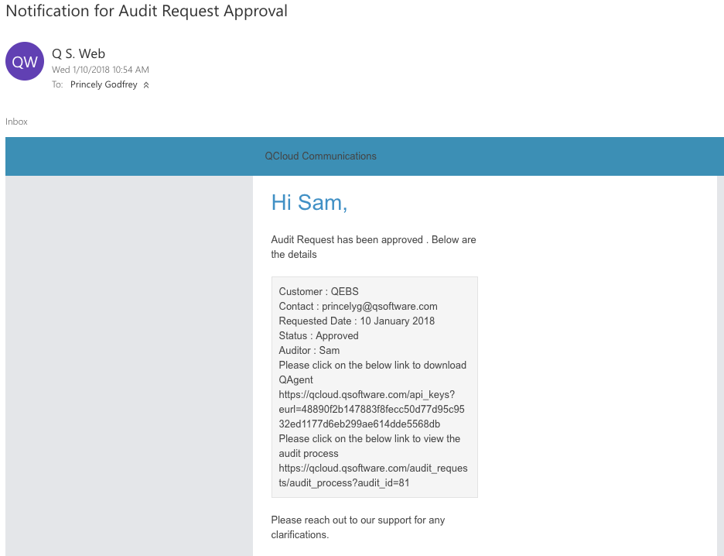

Step 1: Click on the highlighted link in the mail to download the QAgent

Step 2: You will be able to view the button ‘Download QAgent’ as shown below. Click on the button to download the QAgent.

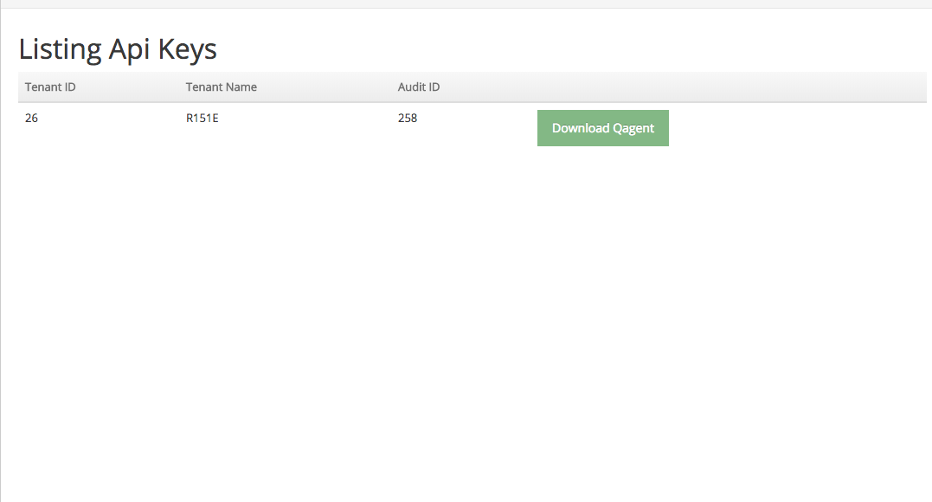

Step 3: Once the QAgent is downloaded, unzip the QAgent.zip file

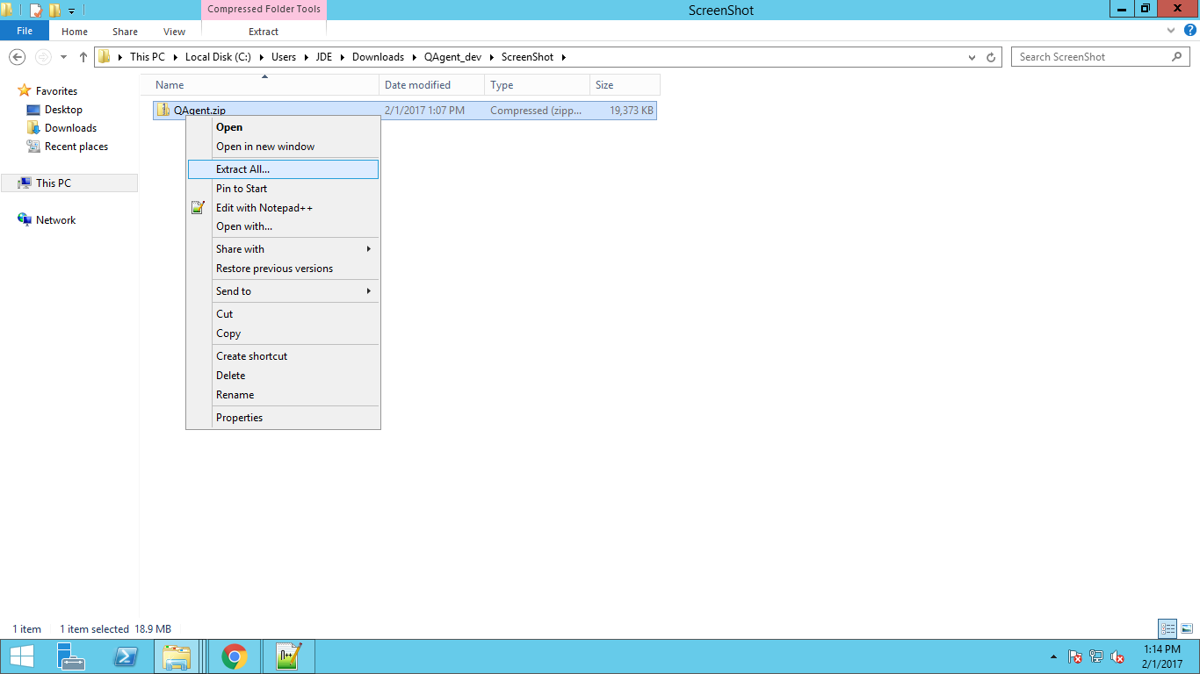

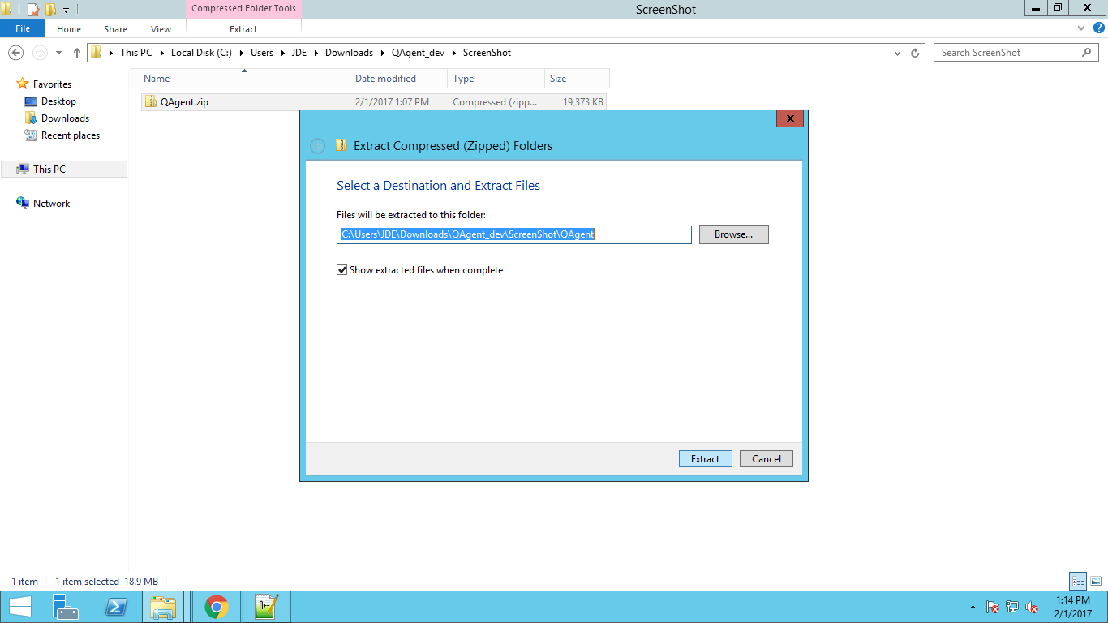

Step 4: After extracting the Qagent.zip, double click on execute.cmd

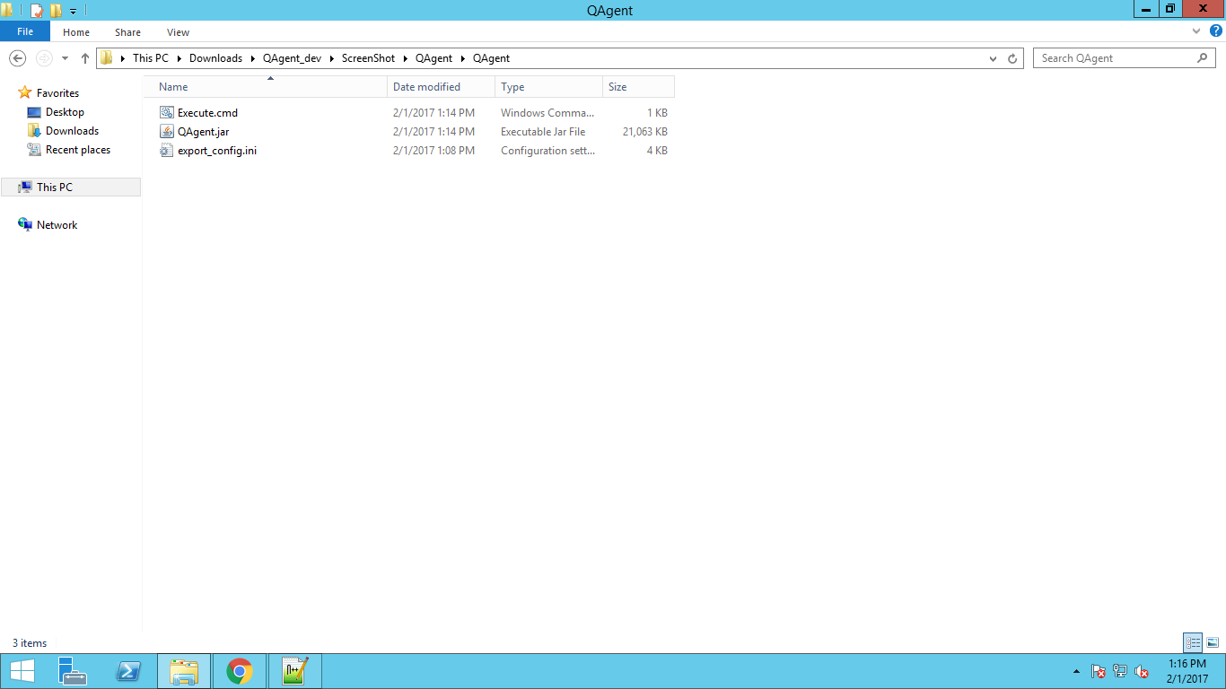

Step 7: Click on ‘Run’

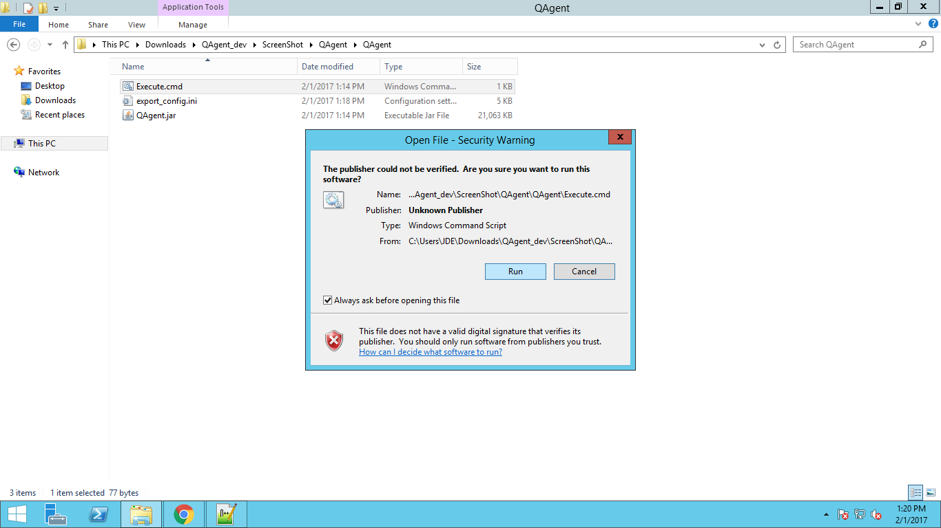

Step 8 : When you click ‘Run’ , the Qagent UI will open.

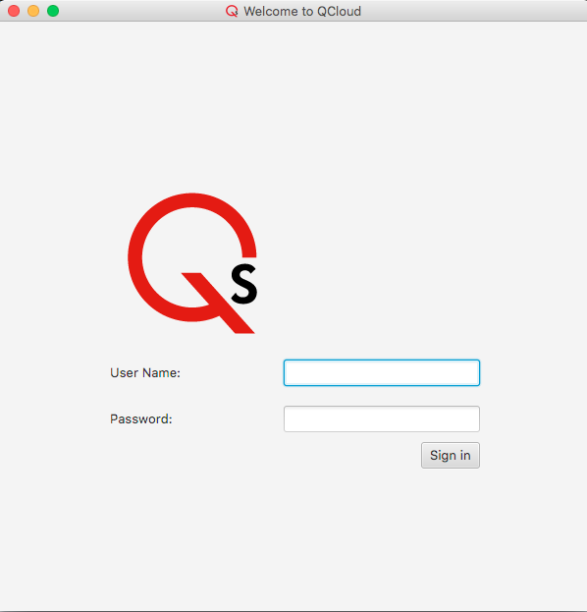

Step 9 : Enter the QCloud User Credentials and click on “Sign in”

1. Once signed in successfully, the Datasource settings grid would show up, where the database details need to be entered. Following which click on ‘save’ button to save the database details.
2. Each of Datasource settings needs to be entered and saved.
3. Once the database details are saved and validated successfully, the database details would be cached after which the audit grid would show up.
4. During subsequent logins, QAgent would refer to the cached values to auto load and validate the same.

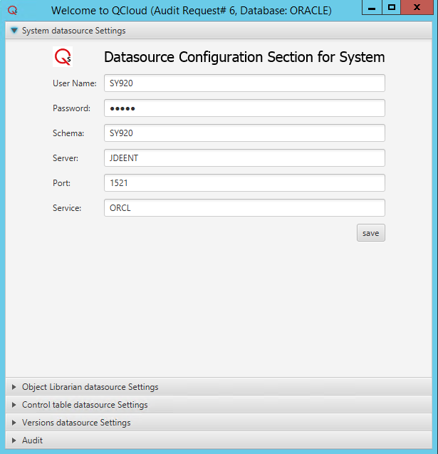

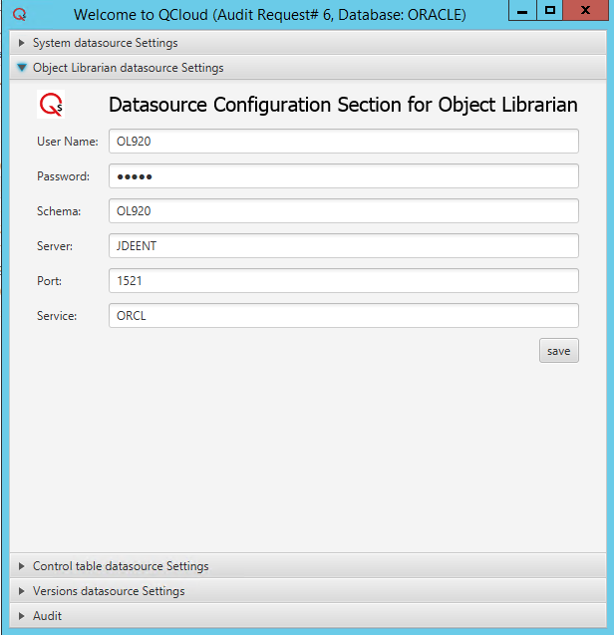

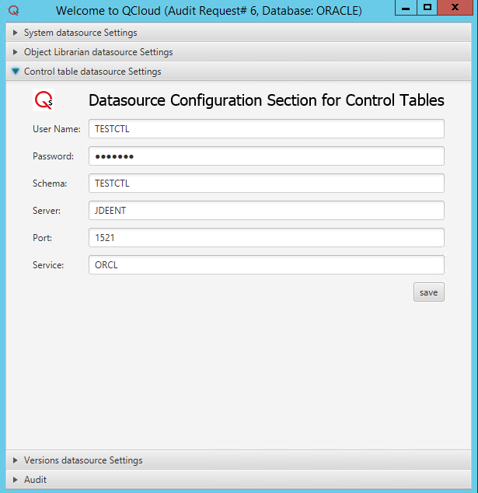

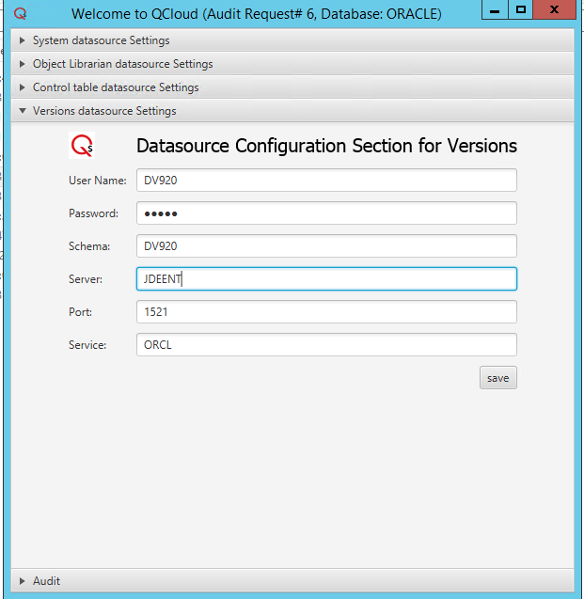

**User name** = The username with which the database has to be connected (Preferably the user having Read only access)

**Password** = The password for the user.

**Schema** = The schema name.

**Server** = The name of the database server

**Port** = 1521 (Default port for oracle), if the port is different from the default port then the correct port has to be provided.

**Service** = The service name which was configured when installing the database. This information should be available in the tnsnames.ora file.

Step 11 : Click on the Play button to start the audit

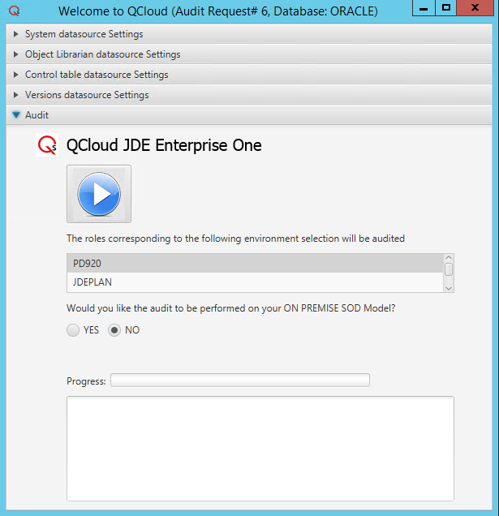

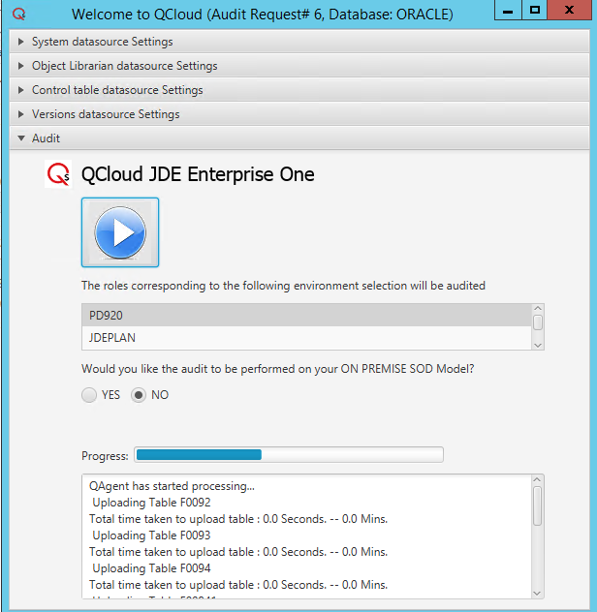

Once the upload of data is complete, the progress bar will show 100 % & an appropriate message indicating that the QSG file was uploaded into S3.

5.3 Firewall access required for QAgent

QAgent would need access to the following sites for the JDE Customer Data to be processed successfully.

1. qcloud.qsoftware.com
2. qsoft.qcloud.audit-file.s3-us-east-1.amazonaws.com
3. qsoft.qcloud.audit-file.s3.amazonaws.com